SYDNEY SOUTH PLANNING PANEL – SUPPLEMENTARY ASSESSMENT REPORT
Panel Reference | PPSSSH-80
DA Number | DA-512/2021
LGA | Canterbury Bankstown Council
Proposed Development | Demolition of all existing structures, excavation, site remediation, new road, removal of 23 trees, site landscaping and construction of 138 units with 62 terraces and residential flat buildings for 76 units over a single level basement car park
Street Address | 165-171 Milton Street, Ashbury
Applicant/Owner | Mecone/Ashbury Developments Pty Limited
Date of DA lodgement | 7 July 2021
Number of Submissions | 31 Submissions
Recommendation | Approval
Regional Development Criteria (Schedule 7 of the SEPP (State and Regional Development)  2011 | Part 2.4 clause 2.20 and Schedule 6 in SEPP (Planning Systems) 2021 the application is declared as regionally significant development. Schedule 7 includes ‘General Development over $30 million’. The proposed capital investment value of $62,395,506 and falls within this category.
List of all relevant s4.15(1)(a) matters | - State Environmental Planning Policy (Planning Systems) 2021  - Water Management Act 2000  - State Environmental Planning Policy (Resilience and Hazards) 2021  - State Environmental Planning Policy 65 – Design Quality of Residential Apartment Development (SEPP 65)  - State Environmental Planning Policy 2004 (Building Sustainability Index: BASIX)  - Canterbury Local Environmental Plan 2012 (CLEP 2012)  - Canterbury Development Control Plan 2012 (CDCP 2012)  - Canterbury Development Contributions Plan 2013 (Contributions Plan 2013)
List all documents submitted with this report for the Panel’s consideration | - Attachment 1 – Council’s Assessment Report
Summary of key submissions | - Removal of significant trees on site.  - Loss of on-street parking along Milton Street  - Privacy impacts from roof top terraces  - Overshadowing on POS areas of existing neighbouring dwelling
houses
• Traffic Impacts
Report prepared by | Kaitlin McCaffery – Senior Planner and George Gouvatsos Coordinator Planning (East)
Report date | 4 July 2022

SUMMARY
This supplementary report is to respond to the Panel’s deferral of the development application at its meeting on 7 June 2022.

BACKGROUND
The Panel at its meeting on 7 June 2022 deferred the determination of the development application until the drained basement specification is approved by WaterNSW as this was not available at the time of the public meeting.

The Panel also requested information to clarify the proposed height of the buildings adjoining the Trevenar St properties, as raised by the objectors at the public meeting.

REPORT
The applicant has submitted the following southwest boundary study which shows the relationship with the adjoining properties at 21 -31 Trevenar St, Ashbury

There is an existing retaining wall that was part of the previous industrial building which will be retained for the length along part boundary at 25 to 31 Trevenar St. This is to retain the existing established trees in this location which will assist in providing privacy at the boundary with the adjoining dwellings.

The retaining wall will be demolished along the boundary at 21 to 25 Trevenar St and the land will slope gradually to match the adjoining properties on Trevenar st. The buildings will be setback 11.670m from the Trevenar St southern boundary.

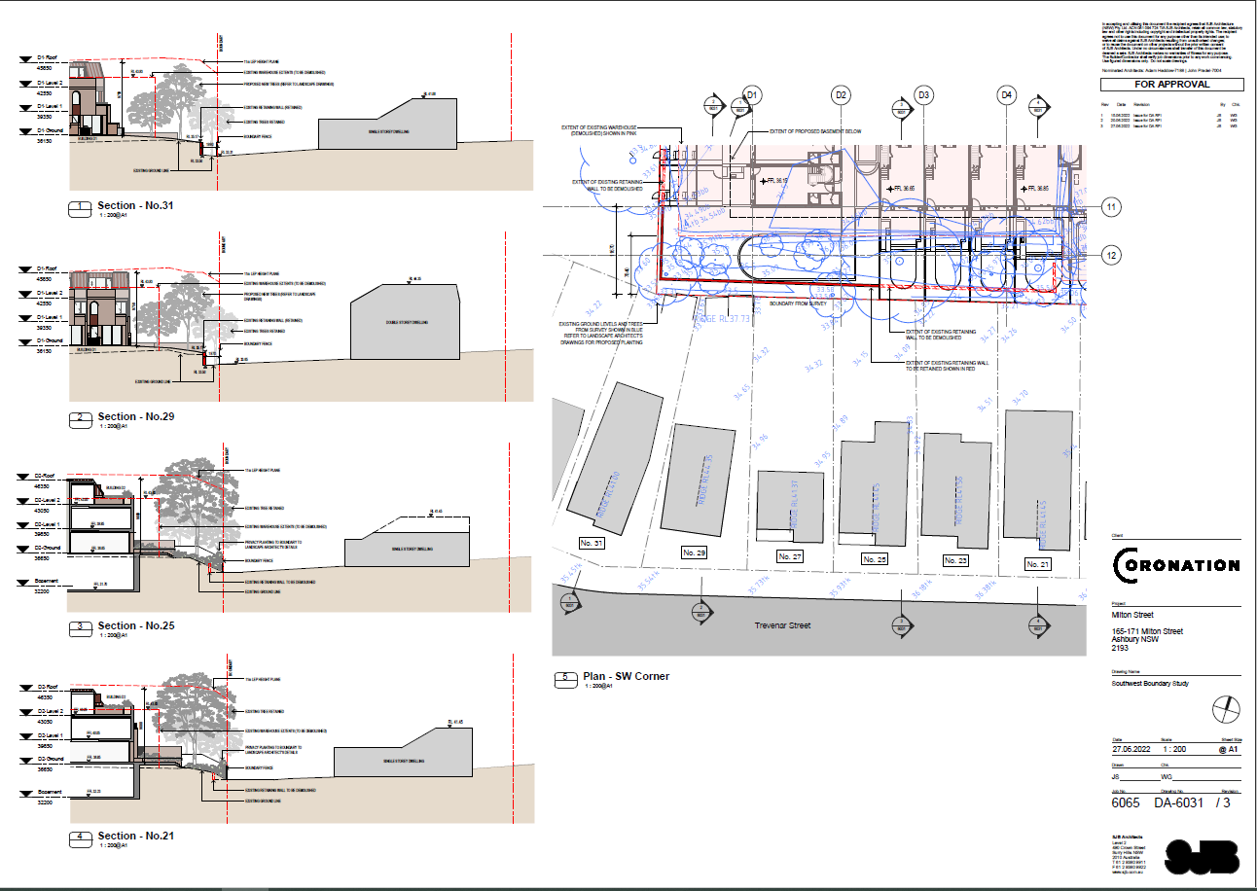

The relationship between the proposed development and the adjoining properties is considered acceptable given the design which includes the appropriate separation distances, fencing and landscaping treatment to mitigate any privacy concerns.

Council was furnished with the General Terms of Agreement from WaterNSW on 7 July 2022 and these have included at condition 1.15

The applicant has addressed the matters of deferral and the application can now be determined.

RECOMMENDATION
It is recommended that the Panel support Councils recommendation to approve the application as outlined in the assessment report and as per the amended conditions of consent.

